[edit letter to fit your school situation]

[insert date]

Dear Parents,

I am writing to invite you and your child to attend Youth Technology Day on [insert date] from [start time] to [end time] at the SUNY Oswego Department of Technology Education in the School of Education. Youth Technology Day is an opportunity for you and your child to visit the Department of Technology on the SUNY Oswego campus and learn about their programs, while participating in challenging hands-on technology activities that are planned and directed by pre-service technology education teachers. The pre-service technology teachers, enrolled in teaching methods course, are all junior or senior level, and one semester away from student teaching. Mark Springston and Michael Nehring, SUNY Oswego professors, instruct the pre-service technology teachers on organizing Youth Technology Day.

For the hands-on technology activities, your child may use common classroom items, such as scissors, glue, hot-melt adhesive, soldering pen, handsaw, and Xacto knives. However, your child will not use power machinery (e.g., drill press). Your child will be under adult supervision during all activities.

We will also photograph some of the activities for possible use in future Mexico High School or SUNY Oswego publications. The SUNY Oswego teaching methods students are also distributed the photos for possible use in professional education portfolios. However, no last name will be associated with your child. Your child’s first name may be included in a photo due to students wearing nametags. If you do not wish to have your child included in such publications, please sign the appropriate line on the attached permission form.

You are welcome to observe all or some of the activities, but you are not required to attend for your son or daughter to participate. We ask that all parents sign and complete the attached permission form, and then return it to [insert name] no lather than [insert date]. If you have any questions or concerns, please do not hesitate to contact me at [insert phone number].

Sincerely,

[insert name]

Campus Map and Wilber Hall

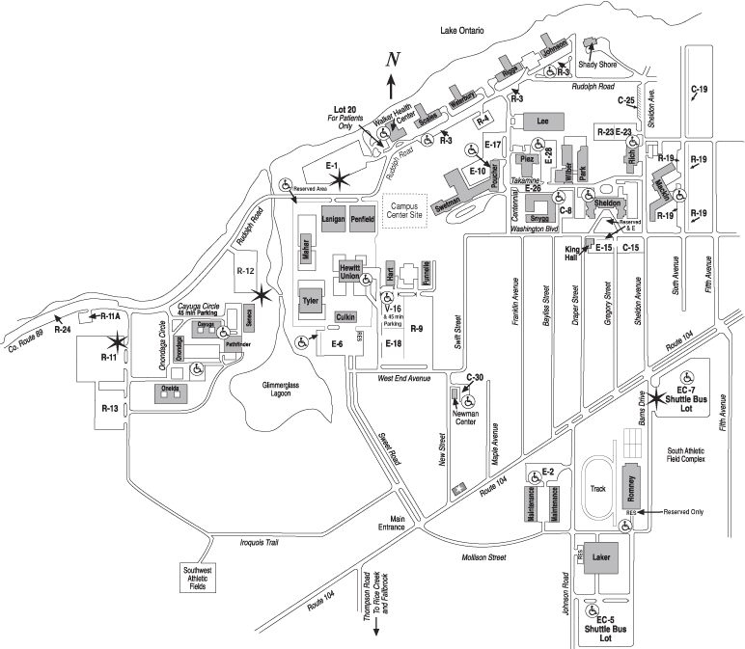
YTD2
YTD1
Please come to Wilber Hall
Wilber Hall
If you do not have a visitor’s parking pass, please obtain one here.

Youth Technology Day Parental Permission Form

Attendance Permission
I have read the attached letter on Youth Technology Day. My child, , has my permission to attend on [insert date].
Please print your child’s name above

Please print your name above
Please sign your name above

Permission to Use Photographs
We request permission to use photographs of your son or daughter in department related publications. These publications may be disseminated to larger audiences through media such as the Internet, brochure, or promotional disks. The resulting material will become the property of the Department of Technology at SUNY Oswego. However, I further understand that none of my personal or my child’s information, such as last name, will be associated with any photo. First name may be included due to students wearing nametags. Please sign one of the following:

I grant permission to use photographs:
Please sign your name above

I do not grant permission to use photographs:
Please sign your name above

Note. If you do not agree, [insert name] will identify which photos include your son or daughter, so they can be deleted after Youth Technology Day.

Please sign and detach this page, and then return it to [insert name].

